BBF PI & Coordinator Package:
Political Will Gear

This package contains information regarding the Political Will Gear (PWG) intended for the in-country BBF Team (PI, Coordinator and Research and/or Administrative Assistant) and BBF Committee Members. It is organized into the following sections:

- General description of the Political Will Gear
- Political Will Gear Benchmarks and Examples - Table of all PWG Benchmarks, scoring information and examples
- Identification of Available Data- This template is to help the coordinator(s) in identifying the available data prior to the 1st Meeting. The BBF committee will use this form during that 1st Meeting to determine a) what remaining information is necessary and b) the actual benchmark scores. Provide as much detail as possible when completing this form to facilitate an efficient data gathering process.
- Data Gathering Action Plan- During the 1st Meeting, Gear Teams will set out their strategy to gather the remaining information required to score each benchmark to ensure efficient and comprehensive data collection. This plan should specify who is responsible, the likely data needed, the data collection strategy for each member, and the anticipated deadlines for collection.
- Data Organization and Benchmark Scoring Pathways- The purpose of the Data Organization templates are to help organize all the information collected for each benchmark and are intended to capture the multidimensional nature of each benchmark. The project coordinator ensures all data is available for the Gear Teams and they complete these forms. Teams will then use them in conjunction with the Scoring Pathways and corresponding tables to reach the benchmark score.

Scoring Pathways are designed to assist with the actual scoring - follow the arrows in order to score the benchmark. The corresponding tables are for documenting discussion, any changes to the scores, the scoring justification and final score. Gear Teams will summarize and present the results to the BBF committee during the 2nd and 3rd Meetings in order to facilitate consensus on benchmark scores.

- PWG1
- PWG2
- PWG3

- Recommended Actions - This table is for Gear Teams to outline/describe their proposed actions to address the gaps identified for the gear as a whole. These recommendations will form the basis of each Gear Team’s presentation during Meeting 4.
General description of the Political Will Gear (PWG)

Key question: Have policy makers expressed commitment to scale up in-country breastfeeding efforts?

Background

Political will “exists when a sufficient set of decision makers with a common understanding of a particular problem on the formal agenda is committed to supporting a commonly perceived, potentially effective policy solution”. ¹⁴ According to Post et al. ¹⁴, this complex, multifactorial phenomenon is comprised of three factors, which help conceptualize political will: a) the distribution of preferences of policymakers (i.e. what are the preferences of acting politicians and will others accept the policies); b) the authority, capacity, and legitimacy of key decision makers or reformers (i.e. political will is only strong if political power and resources are available); and c) commitment to preferences (i.e. how a policymaker stands up for his/her beliefs; how resources and other efforts are allocated; what incentives/disincentives are provided to the policymaker for adopting a position).

The BFGM posits that the Political Will Gear results when advocacy is strong enough to generate momentum that elicits political commitment from policy makers to protect, promote and support breastfeeding. In turn, strong political will is needed to enact legislation and policies to protect, promote and support breastfeeding.⁶ Only when “expressed commitment” (i.e. “verbal declarations of support for an issue by high-level, influential political leaders”), “institutional commitment” (i.e. policies and organizational infrastructure), and “budgetary commitment” (i.e. monies have been allocated towards a particular cause) are present is there full and complete political commitment towards a cause, such as breastfeeding.¹⁰

Measuring political will is complex and indirect, typically by examining the political commitment of decision makers. While political commitment is comprised of “expressed commitment”, “institutional commitment” and “budgetary commitment”¹⁰, these reflect separate gears within the BFGM corresponding to “political will”, “legislation and policies”, and “funding & resources” respectively. Thus, measuring political will for the BFGM consists of evaluating the level of expressed commitment policymakers have towards scaling-up breastfeeding.

Benchmarks

The Political Will Gear measures expressed commitment by the government to protect, promote and support breastfeeding scaling up efforts assessed through three benchmarks. All benchmarks are referenced to “the past year” unless otherwise noted.

Domains

The benchmarks are designed to measure gear progress and they all have one or more Domain that assesses the different dimensions or elements within each benchmark:
Volume/Frequency: measures how much or how often
Quality: measures the quality of implementation
Effective (Operational): measures the adoption or level of incorporation
Existence: measure the actual presence of a program, legislation, policy, strategy, person, etc.
Coverage: measures the level of implementation (national, subnational, local)

Political Will Gear (PWG) Benchmarks and examples

Benchmark | Benchmark Scoring |  |  |  |  | Examples
 | 0  Not done | 1  Minimal progress | 2  Partial progress |  | 3  Major progress
PWG1:  High level political officials have publicly expressed their commitment to breastfeeding action | High level political officials have not publicly expressed their commitment to breastfeeding action at all | High level political officials have publicly spoken about breastfeeding but have not expressed their commitment to breastfeeding action. | High level political officials have publicly expressed their commitment to breastfeeding action once. | High level political officials have publicly expressed their commitment to breastfeeding action at least twice. |  | In 2011, First Lady Michelle Obama launched a breastfeeding campaign to support nursing mothers. The campaign recognizes the health benefits of breastfeeding and identifies its association with lowering the risks of childhood obesity, which coincides with Mrs. Obama’s “Let’s Move!” initiative. She cited needing more breastfeeding education, specifically for women in predominately black communities, according to Mrs. Obama, “40% of [black] babies never get breastfed at all.” She also has pushed for more hospitals to be certified as “Baby Friendly” and more flexible workplace rules for breastfeeding. Mrs. Obama has publicly expressed her commitment to breastfeeding action multiples times throughout the year.  Score: Major Progress  Existence: Yes  Volume: US First Lady is considered a high-level official and she verbally promoted breastfeeding more than two times in one year.  Quality: Mrs. Obama publicly expressed her commitment to action by including breastfeeding in her obesity initiative.
PWG2:  Government initiatives have been implemented to create an enabling environment that promotes breastfeeding | No government initiatives have been implemented to create an enabling environment that promotes breastfeeding | A few government initiatives have been implemented but they do not create an enabling environment that promotes breastfeeding | Several government initiatives have been implemented and they have started to create an enabling environment that promotes breastfeeding |  | Several government initiatives have been implemented and they create a strong enabling environment that promotes breastfeeding | In 2016, Mexico BBF committee considered the initiatives that enable a breastfeeding environment, i.e. those actions that the government implemented to eliminate barriers to breastfeeding in Mexico. Six specific barriers and initiatives were identified through the literature:  1) Barrier: Type of birth and inadequate hospital practices (e.g. formula feeding during post-birth recovery).  Impact: Progress has been made in certifying baby-friendly hospitals. As of April 2016, 107 hospitals were nominated, an advance of almost 30% over the target but the levels are still low nor has BFHI been implemented in health centers.  2) Barrier: Lack of breastfeeding counseling. Impact: 84.6% of mothers know at least one benefit of breastfeeding and 88.6% have received pre or postnatal breastfeeding counseling. However, it is unclear if counselors are trained and whether the counseling itself is pro-breastfeeding.  3) Barrier: Lack of efficient health care and cross cultural support, mainly for indigenous and rural communities. Impact: 87.3% indigenous mothers were visited 5 times in the prenatal period by a trained health worker. This data does not provide information on the efficiency of the care or it’s specific reference to multiculturalism.  4) Barrier: Lack of appropriate spaces for breastfeeding when women return to work. Impact: Guidance was issued to address this but few companies have appropriate spaces for breastfeeding.  5) Barrier: Lack of laws to protect lactation among working women. Impact: BBF Committee agrees that while on the paper there are advances, in reality these laws have not been implemented.  6) Barrier: Lack of monitoring of the compliance of the International Code. Impact: Government has relied on self-regulation by the formula industry and does not monitor nor has an action plan to better implement the Code.  Score: Partial Progress  Domain- Existence: Yes  Domain- Effective: Several government initiatives have been implemented and they have started to create an enabling environment that promotes breastfeeding at the national level.
PWG3:  An individual within the government has been especially influential in promoting, developing, or designing breastfeeding policy. | There is no individual or a collective group of individuals within the government who has been influential in promoting, developing, or designing breastfeeding policy. | There is an individual or a collective group of individuals within the government who has been minimally influential in promoting, developing, or designing breastfeeding policy. | There is an individual or a collective group of individuals within the government who has been partially influential in promoting, developing, or designing breastfeeding policy. |  | There is an individual or a collective group of individuals within the government who has been strongly influential in promoting, developing, or designing breastfeeding policy. | Senator Cayetano of the Philippines is an example of a breastfeeding champion who has used her position in the national government to protect, promote, and support women’s right to breastfeed. She was the principal author of the Expanded Breastfeeding Promotion Act and sponsored the Expanded Maternity Leave Bill, developed by the Senate Committee on Women, of whom she is Chair. She also: a) sponsored a bill to ensure there is one midwife in every health station per 5,000 people, in order to help the Philippines reach its Millennium Development Goal of improving maternal and neonatal health outcomes, b) a resolution asking the legislature to launch an inquiry into Milk Code violations and c) succeeded in getting “gender provisions’ into the ‘Philippine Disaster Risk Reduction and Management Act of 2010’.  Score: Major Progress  Domain- Existence: Yes  Domain- Effective: Senator Cayetano had a strong level of impact on promoting, developing and implementing expansion of the maternity leave legislation.

Identification of Available Data
Political Will Gear
This template is to help the coordinator in identifying the available data the national BBF committee will use to score the PG benchmarks. Provide as much detail as possible when completing this form to facilitate an efficient data gathering process.
Instructions: For each benchmark, the data required is described. Indicate in the Available Data column if that data is available: Yes (Y), No (N), Incomplete (I) or Don’t Know (DK).
Benchmark | Description of required data | Available Data  (Y/N/I/DK) | Reference/Data Sources  Describe where this data is located (e.g. website, report, person to interview, etc.)
PWG1:  High level political officials have publicly expressed their commitment to breastfeeding action | Domain: Existence:  Who are the officials? What was the content?  Domain: Volume:  When/how often did the individual speak publicly about breastfeeding OR public express commitment?
PWG2:  Government initiatives have been implemented to create an enabling environment that promotes breastfeeding | Domain: Existence:  What are the initiatives?  Domain: Effective:  Have the initiatives been implemented fully? Do the initiatives support an enabling environment for BF, i.e. do they encourage breastfeeding and discourage alternative feeding methods by removing structural and societal barriers that interfere with women’s ability to breastfeed optimally?
NOTE 1: Initiatives refer to agenda setting, policy development and program(s) support events.

NOTE 2: Implemented means fully operational and on-going.

NOTE 3: An enabling environment for breastfeeding includes interventions /initiatives related to (1) social mobilization and mass media, (2) legislation, policy, financing, monitoring, and enforcement and (3) counselling, support, and lactation management.

PWG3: An individual within the government has been especially influential in promoting, developing, or designing breastfeeding policy. | Domain: Existence:  Who is the individual? What is their job?  Domain: Effective:  How and when did they promote, develop and/or design policy? What was their role in this? What stage is the policy at, ie. promoted, developed or implemented?

Data Gathering Action Plan
Political Will Gear (PWG)

This plan describes the strategy to gather information required to score each benchmark. The action plan must include a schedule of regular meetings or conference calls made in the intervening two months between Meeting 1 and Meeting 2. It is during this period that the Gear Teams must score their benchmarks.

Gear Team Members:

Benchmark | Assigned Team member(s) | Potential Data Sources | Data Collection Strategy
PWG1: High level political officials have publicly expressed their commitment to breastfeeding action
PWG2: Government initiatives have been implemented to create an enabling environment that promotes breastfeeding
PWG3: An individual within the government has been especially influential in promoting, developing, or designing breastfeeding policy.

Scheduled Meetings: Describe the dates/times, methods (i.e., skype, in person) and content of anticipated meetings.
Date | Time | Method  (skype, in person, etc.) | Meeting agenda items | Anticipated attendees

Data Organization & Scoring Pathways
Political Will Gear
Data Organization: Please provide as much detail as possible to facilitate accurate scoring of each benchmark and development of recommendations. The relevant Domains are in bold.
PWG1: High level political officials have publicly expressed their commitment to breastfeeding action
Existence:  Names of public officials | Existence:  Was this publicly speaking about BF AND/OR expressing their commitment to action(s)? | Existence:  Describe the public speech AND/OR the commitment for action that was expressed | Volume:  Explain when the public speaking AND/OR expressed commitment(s) occurred | References/ Data sources

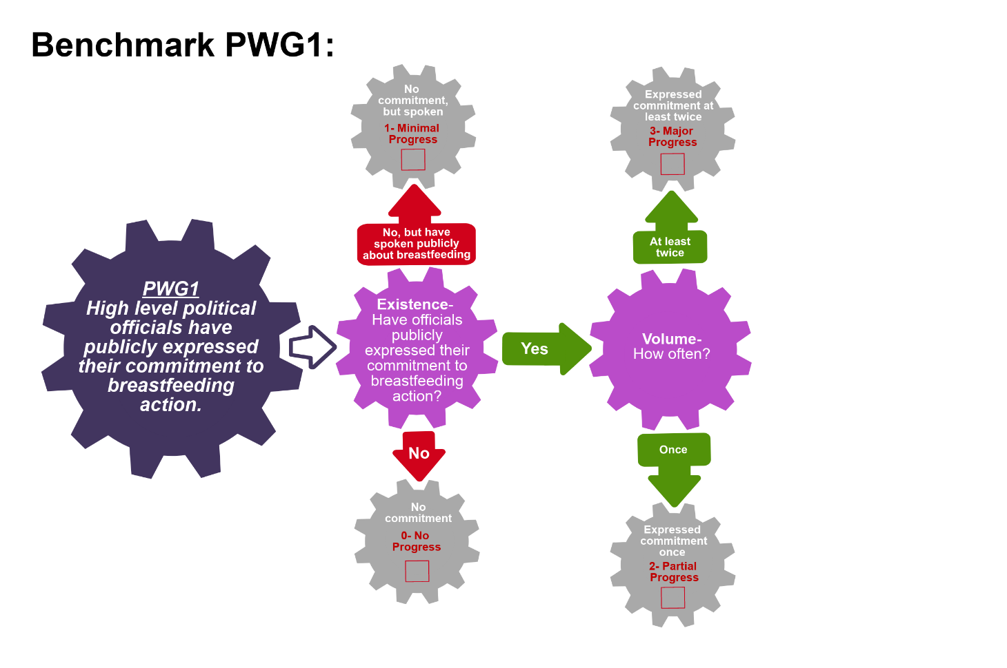
Scoring Pathway
☐

☐

☐
☐

**Insert the final score into the BBFI Calculator**
Instructions: Using the pathway, explain below the evolution of the final agreed score, i.e. rationale for any changes to the score, how the score was calculated (domains and criteria met), gaps identified and address any discrepancies of opinion within the Gear Team or Committee on the final score.
Date | Primary Score | Summary of Discussion | Scoring Justification | Final Score | Gaps identified
Between Meeting1 and 2

Date:
Meeting 2

Date:
Meeting 3

Date:

Data Organization: Please provide as much detail as possible to facilitate accurate scoring of each benchmark and development of recommendations. The relevant Domains are in bold.
PWG2: Government initiatives have been implemented to create an enabling environment that promotes breastfeeding
NOTE: Implemented means fully operational and on-going. Initiatives refer to agenda setting, policy development and program(s) support events. An enabling environment for breastfeeding includes interventions /initiatives related to (1) social mobilization and mass media, (2) legislation, policy, financing, monitoring, and enforcement and (3) counselling, support, and lactation management.
Existence:  List the enabling government initiatives | Effective:  Explain how these initiatives enable BF | Effective:  Describe the implementation process | References/ Data sources

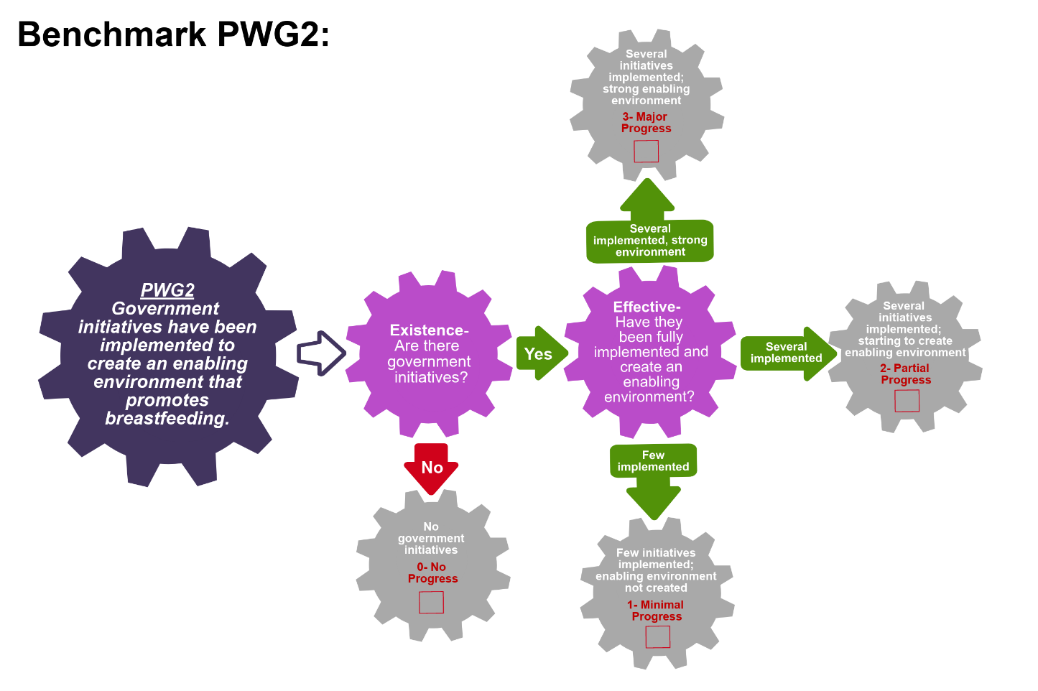
Scoring Pathway

☐
☐
☐

☐

**Insert the final score into the BBFI Calculator**
Instructions: Using the pathway, explain below the evolution of the final agreed score, i.e. rationale for any changes to the score, how the score was calculated (domains and criteria met), gaps identified and address any discrepancies of opinion within the Gear Team or Committee on the final score.
Date | Primary Score | Summary of Discussion | Scoring Justification | Final Score | Gaps identified
Between Meeting1 and 2

Date:
Meeting 2

Date:
Meeting 3

Date:

Data Organization: Please provide as much detail as possible to facilitate accurate scoring of each benchmark and development of recommendations. The relevant Domains are in bold.
PWG3: An individual within the government has been especially influential in promoting, developing, or designing breastfeeding policy.
Existence:  Name the individual and their job title | Effective:  Describe the policy they promoted, developed and/or designed | Effective:  Describe their role within the policy’s advocacy, creation, and/or implementation | Effective:  Describe the stage the policy is currently at, i.e. designed, promoted or fully implemented | References/Data Sources

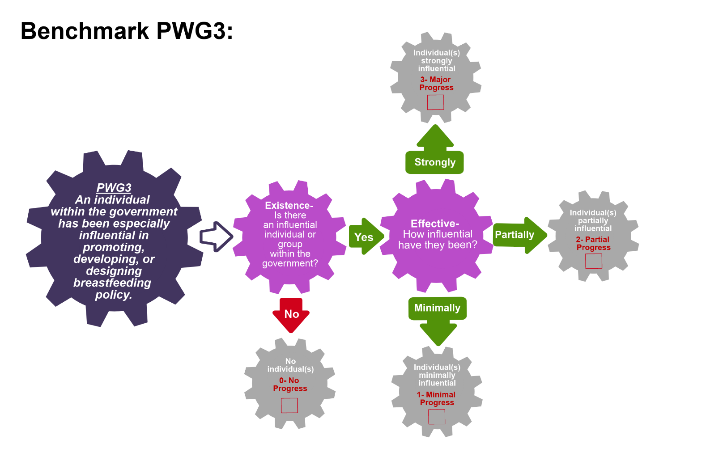
Scoring Pathway

☐

☐
☐
☐

**Insert the final score into the BBFI Calculator**
Instructions: Using the pathway, explain below the evolution of the final agreed score, i.e. rationale for any changes to the score, how the score was calculated (domains and criteria met), gaps identified and address any discrepancies of opinion within the Gear Team or Committee on the final score.
Date | Primary Score | Summary of Discussion | Scoring Justification | Final Score | Gaps identified
Between Meeting1 and 2

Date:
Meeting 2

Date:
Meeting 3

Date:

Recommended Actions
Political Will Gear (PWG)

This template can be used to summarize possible recommendations for improvement where benchmarks have scored No Progress (0), Minimal Progress (1) or Partial Progress (2). This summary will form the basis of each Gear Team’s presentation during Meeting 4. Guidance will be made available on developing recommendations and prioritizing them.

Gaps Identified | Recommended Actions

Adapted from Fox et al. (2015)

