BBF PI & Coordinator Package:
Legislation and Policies Gear

This package contains information regarding the Legislation and Policies Gear (LPG) intended for the in-country BBF Team, comprising the PI, Coordinator and Research and/or Administrative Assistant and is organized into the following sections:

- General description of the Legislation and Policies Gear
- Legislation and Policies Gear Benchmarks and Examples - Table of all LPG Benchmarks, scoring information and examples
- Identification of Available Data- This template is to help the coordinator(s) in identifying the available data prior to the 1st Meeting. The BBF committee will use this form during that 1st Meeting to determine a) what remaining information is necessary and b) the actual benchmark scores. Provide as much detail as possible when completing this form to facilitate an efficient data gathering process.
- Data Gathering Action Plan- During the 1st Meeting, Gear Teams will set out their strategy to gather the remaining information required to score each benchmark to ensure efficient and comprehensive data collection. This plan should specify who is responsible, the likely data needed, the data collection strategy for each member, and the anticipated deadlines for collection.
- Data Organization and Benchmark Scoring Pathways- The purpose of the Data Organization templates are to help organize all the information collected for each benchmark and are intended to capture the multidimensional nature of each benchmark. The project coordinator ensures all data is available for the Gear Teams and they complete these forms. Teams will then use them in conjunction with the Scoring Pathways and corresponding tables to reach the benchmark score.

Scoring Pathways are designed to assist with the actual scoring - follow the arrows in order to score the benchmark. The corresponding tables are for documenting discussion, any changes to the scores, the scoring justification and final score. Gear Teams will summarize and present the results to the BBF committee during the 2nd and 3rd Meetings in order to facilitate consensus on benchmark scores.
- LPG1
- LPG2
- LPG3
- LPG4
- LPG5
- LPG6
- LPG7
- LPG8
- LPG9
- LPG10
- Recommended Actions - This table is for Gear Teams to outline/describe their proposed actions to address the gaps identified for the gear as a whole. These recommendations will form the basis of each Gear Team’s presentation during Meeting 4.
General description of the Legislation and Policies Gear (LPG)

Key questions: Are there national policies and legislation that protect, promote and support breastfeeding for mothers, including working mothers? What is the quality and coverage of these policies/legislation?

Background

Establishing and enacting national breastfeeding legislation and policies demonstrates country-level commitment to scaling up, promoting and supporting breastfeeding programs and initiatives. The adoption of national breastfeeding legislation and policies, such as the National Breastfeeding Policy, adoption of the International Code of Marketing of Breast Milk Substitutes, Maternity Protection Legislation, and Baby Friendly Hospital Initiative (BFHI) legislation is one key step countries can take towards improving maternal and child health. To be effective, policies supporting breastfeeding must be officially adopted, integrated into existing health programs, supported through vigorous coordination and monitoring efforts, and enforced if violated. Proper integration and support of legislation and policies requires adequate funding and resources.

Benchmarks

The ten benchmarks for the Legislation and Policies Gear assess the adoption, coverage and quality of key breastfeeding legislation and policies, including national breastfeeding policy, BFHI, the International Code of Marketing of Breast Milk Substitutes, and national maternity protection laws. All benchmarks are referenced to “the past year” unless otherwise noted.

Domains

The benchmarks are designed to measure gear progress and they all have one or more Domain that assesses the different dimensions or elements within each benchmark:
Volume/Frequency: measures how much or how often
Quality: measures the quality of implementation
Effective (Operational): measures the adoption or level of incorporation
Existence: measure the actual presence of a program, legislation, policy, strategy, person, etc.
Coverage: measures the level of implementation (national, subnational, local)

Legislation and Policies Gear (LPG) Benchmarks and examples

Benchmark | Benchmark Scoring |  |  |  |  |  | Examples
 | 0  Not done |  | 1  Minimal progress |  | 2  Partial progress | 3  Major progress
LPG1:  A national policy on breastfeeding has been officially adopted/  approved by the government. | There is no national policy on breastfeeding |  | A national policy on breastfeeding is under discussion. |  | A national policy on breastfeeding has been written but it has not been officially adopted/  approved by the government. | A national policy on breastfeeding has been written and has been officially adopted/  approved by the government. | Malta developed a National Breastfeeding Policy for 2015 - 2020 that includes an Action Plan to implement the policy. The policy was developed through an extensive national process of consultation. The policy “recognizes the biological, health, social, cultural, environmental and economic importance of breastfeeding. It also provides direction for priorities and action for the Maltese government at all levels working in partnership with mothers and society to promote, protect, support and maintain breastfeeding.”  Score: Major Progress  Existence: Yes  Effective: National policy on breastfeeding is written and as it is a government document, it is officially adopted/approved by the government.
LPG2:  There is a national breastfeeding plan of action. | There is no national breastfeeding plan of action. |  | Some strategies in the national breastfeeding plan of action are implemented but the plan does not contain measurable nor time bound objectives/targets. |  | Some strategies in the national breastfeeding plan of action are implemented and the plan contains measurable objectives/ targets and time bound | All strategies in the national breastfeeding plan of action are implemented and the plan contains measurable and time bound objectives/targets. | The Philippine IYCF Strategic Plan of Action 2011-2106 is an example of an action plan with measurable, time-bound objectives and detail on the actions, interventions, collaborations and internal structural arrangements necessary to achieve the strategic breastfeeding objectives within the national health strategy.  Score: Partial Progress  Existence: Yes  Quality: National breastfeeding plan of action contains measurable and time bound objectives/targets and, according to the WBTi report, some strategies have been implemented.
LPG3:  The national BFHI/Ten Steps criteria has been adopted and incorporated within the healthcare system strategies/  policy. | There is no national BFHI/Ten Steps criteria. |  | A national BFHI/Ten Steps criteria exists and is consistent with BFHI WHO/UNICEF  global criteria, or it has been adopted but it has not been incorporated into the healthcare system strategies/  policies nationally. |  | A national BFHI/Ten Steps criteria exists and is consistent with BFHI WHO/UNICEF global criteria, it has been adopted and it has been partially incorporated into the healthcare system strategies/  policies nationally. | A national BFHI/Ten Steps criteria exists, is consistent with BFHI WHO/ UNICEF global criteria, and it has been adopted and incorporated into the healthcare system strategies/  policies nationally. | On May 22, 2014, the Brazilian Ministry of Health put forth a decree (#1,153) that acknowledges the Baby Friendly Hospital Initiative (BFHI). In Brazil, BFHI is a strategy to promote, protect and support breastfeeding as well as the health of children and women within the Unified Health System. This Decree includes the BFHI as a Health Program in the context of other Health Policies and Programs as the Program for Humanization of Prenatal and birth, Health Care Network, Stork Network, Primary Care for the Family Health Strategy and the Program of Community Health Agents. It is consistent with the BFHI WHO/UNICEF global criteria.  Score: Major Progress  Existence: Yes  Effective: Part of the unified health system strategies  Quality: Consistent with BFHI WHO/UNICEF global criteria
LPG4:  The International Code of Marketing of Breast Milk Substitutes has been adopted in legislation. | The International Code of Marketing of Breast Milk Substitutes (The Code) has not been adopted in legislation. |  | The Code has been adopted in legislation but does not include all provisions of the Code nor provisions for a monitoring system, penalties for violations, and reporting of violators. |  | The Code has been adopted in legislation and includes all provisions of the Code but not provisions for a monitoring system, penalties for violations, and reporting of violators. | The Code has been adopted in legislation and includes all provisions of the Code and provisions for a monitoring system, penalties for violations, and reporting of violators. | In the case of Mexico, the adopted Code only covers formulas for children 0-6 months, even though WHO Code states that it should cover all formulas and products for children <24 months. In the most recent Health Assembly, WHO modified the Code to cover children <36 months. Mexico’s regulatory framework includes some provisions related to labelling, promotion and distribution of breastmilk substitutes. However, there are important provisions not included, such as regulatory measures at points of sale and advertising in the media. Also, there are not effective mechanisms for monitoring, reporting and sanctioning against non-compliance. When applied, the sanctions are so insignificant in monetary terms and in the image of companies producing breastmilk substitutes that they are not sufficient to discourage behaviors that violate the Code  Score: Minimal Progress  Existence: Yes  Effective: Includes some provisions of the Code but not but not all of them  Quality: No provisions for a monitoring system, penalties for violations, and reporting of violators.
LPG5:  The National Code of Marketing of Breast Milk Substitutes has been enforced. | The National Code of Marketing of Breast Milk Substitutes has not been enforced. |  | The National Code of Marketing of Breast Milk Substitutes has been minimally enforced; it happens only in a few localities or situations. |  | The National Code of Marketing of Breast Milk Substitutes has been partially enforced; it happens in most of the localities or situations. | The National Code of Marketing of Breast Milk Substitutes has been enforced in the whole country. | In Brazil, the penalties for non-compliance the Code regulation are applied in a progressive manner, according to the severity and frequency of the infraction. The infractions will be punished, alternatively or cumulatively, with: 1) Warning, 2) Fine, 3) Product disuse, 4) Interdiction, 5) Suspension of product sale, 6) Cancellation of product registration, 7) Prohibition of advertising, 8) Imposition of rectifying message, and 9) Suspension of advertising and publicity. The fine is applied in accordance with infraction classification in (a) mild, (b) serious, and (c) extremely serious. In the case of recidivism, the fines will be applied twice. In each sphere of Government (Federal, State, Municipal and District), National Agency of Sanitary Surveillance (Anvisa) has a competent body for the judgment of Administrative Proceedings instituted by its Sanitary Authorities in accordance with the provisions of the Law.  Monitoring of compliance with the legislation to protect breastfeeding has been done in the country every year since 2006. For example, in 2014, IBFAN Brazil in partnership with IDEC (Brazilian Institute of Consumer Protection) conducted a monitoring survey and found 114 infractions to NBCAL (Brazilian Standard for Commercialization of Foods for Infants and Toddlers, Teats Pacifiers and Bottles). In total, 35 companies (located in 10 cities of 5 Brazilian states) were notified of irregularities in products for children under two years that discourage breastfeeding. The results of the monitoring survey were sent to Ministry of Health and National Agency of Sanitary Surveillance (Anvisa) responsible for applying the penalties. Every year Anvisa provide a report about infractions and penalties related with NBCAL.  Score: Major Progress  Coverage: Clear evidence of enforcement undertaken throughout the whole country.
LPG6:  The International Labour Organization Maternity Protection Convention has been ratified. | No maternity protection laws in the country and the Maternity Protection Convention, 2000 (No 183) has not been ratified. |  | Few maternity protection laws meet the provisions of the Maternity Protection Convention, 2000 (No 183) but the Maternity Protection Convention, 2000 (No 183) has not been ratified. |  | Most maternity protection laws meet the provisions of the Maternity Protection Convention, 2000 (No 183) but the Maternity Protection Convention, 2000 No. 3 has not been ratified. | All maternity protection laws meet or exceed the provisions of the Maternity Protection Convention, 2000 (No 183) or the Maternity Protection Convention 2000 has been ratified. | Brazil has signed the first two ILO Conventions, but not the third one. However, the Maternity Protection Law in Brazil covers and, in some cases, surpasses the latest ILO convention recommendations. The law provides for full paid maternal leave (120 to 180 days), full paid paternal leave (5-20 days), environmental protection against risk during pregnancy and breastfeeding, breastfeeding breaks, and job protection (a woman cannot be fired 4 months after delivery).  Score: Major Progress  Existence: Yes  Quality: Maternity protection laws all meet or exceed the provisions of the Maternity Protection Convention, 2000 (No 183).  In Mexico, the ILO Conventions no.103 and no.183 have not been ratified but national legislation does provide for 12 weeks of paid leave at 100% of previous earnings.  Score: Minimal Progress  Existence: No, Convention has not been ratified.  Quality: A few maternity protection laws meet the provisions of the Maternity Protection Convention, 2000 (No 183).
LPG7:  There is paid maternity leave legislation for women. | There is no paid maternity leave legislation for women. |  | There is paid maternity leave legislation for women but it stipulates less than 14 weeks leave and receiving less than 2/3rd of their previous earnings. |  | There is paid maternity leave legislation for women and it stipulates at least 14 weeks leave but receiving less than 2/3rd of their previous earnings OR it stipulates less than 14 weeks but receiving at least 2/3rd of the previous earnings. | There is paid maternity leave legislation for women and it stipulates at least 14 weeks leave AND receiving at least 2/3rd of their previous earnings. | In Sweden, pregnant woman’s benefits can be paid as early as 60 days (two months) into the pregnancy and continue up to 11 days before the due date. The amount received is roughly 80 per cent of the mother’s daily pay and is paid by the Swedish Social Insurance Agency. Parents are entitled to 480 days of paid parental leave when a child is born or adopted. For 390 of the days, parents are entitled to nearly 80% of their normal pay. The remaining 90 days are paid at a flat rate.  Score: Major Progress  Existence: Yes  Quality: Maternity leave is more than 14 weeks and paid in excess of 2/3 of previous earnings.
LPG8:  There is legislation that protects and supports breastfeeding/  expressing breaks for lactating women at work. | There is no legislation that protects and supports breastfeeding/ expressing breaks at work. |  | Labor policies encourage employers to protect and support breastfeeding/ expressing breaks for their workers, but there is no legislation stipulating this. |  | Local legislation protects and supports breastfeeding/ expressing breaks at work. | National legislation protects and supports breastfeeding/ expressing breaks at work. | In New Zealand, under the law, employers are obligated to provide appropriate facilities within the workplace for breastfeeding employees. Employers are also required to provide additional paid breaks for employees that wish to breastfeeding during working hours.  Score: Major Progress  Existence: Yes  Coverage: National legislation protects and supports breastfeeding/ expressing breaks at work.  In Canada, only the provinces of Ontario and British Columbia have laws protecting breastfeeding breaks at work.  Score: Partial Progress  Existence: Yes  Coverage: Local legislation only.
LPG9:  There is legislation for supporting worksite accommodations for breastfeeding women. |  | There is no legislation for supporting worksite  accommodations for breastfeeding. |  | Labor policies encourage employers to support worksite accommodations, including providing alternate work at the same wage until the mother is no longer breastfeeding but there is no legislation stipulating this. | Local legislation supports worksite accommodations, including providing alternate work at the same wage until the mother is no longer breastfeeding | National legislation supports worksite accommodations, including providing alternate work at the same wage until the mother is no longer breastfeeding | Uruguayan Law states that any worker, during pregnancy or breastfeeding, is entitled to a temporary change of job if the health of the mother or child may be affected. This temporary change of job can not affect the woman’s salary and she may not be suspended, fired, or adversely affected in her labor rights or delayed in her career.  Score: Major Progress  Existence: Yes  Coverage: National legislation supports worksite accommodations, including providing alternate work at the same wage until the mother is no longer breastfeeding.
LPG10:  There is legislation providing employment protection and prohibiting employment discrimination against pregnant and breastfeeding women. |  | There is no legislation providing employment protection and prohibiting employment discrimination against pregnant and breastfeeding women. |  | There is legislation prohibiting employment discrimination against pregnant and breastfeeding women but it does not include any employment protections (i.e. against termination, same position and payment, no pregnancy test upon hiring). | There is legislation prohibiting employment discrimination against pregnant and breastfeeding women and it includes some but not all employment protections (i.e. against termination, same position and payment, no pregnancy test upon hiring). | There is legislation prohibiting employment discrimination against pregnant and breastfeeding women which includes all employment protections (i.e. against termination, same position and payment, no pregnancy test upon hiring). | In Mexico, the BBF Committee reviewed the relevant legislation and carried out in-depth interviews with the Secretary of Labor and Social Welfare, the Director of the National Institute of Women, and the President of the National Council for Preventing Discrimination. The national legislation includes all the provisions of protection against the discrimination specified by this benchmark.  However, there is evidence to suggest that the legislation is ineffective and that violations do occur:  According to the National Survey on the Dynamics of Relationships in Households 2011, 3.1% of the workers were dismissed or their salary was reduced due to their pregnancy. Data from the Council to Prevent and Eliminate Discrimination in Mexico City indicate that from 2013 to 2015 there were 423 complaints, of which 163 (38.5%) were related to the dismissal upon returning from maternity leave or during the lactation period.  The BBF Committee recommended the following to address the violations:  • Implement monitoring, supervision and reporting measures to ensure that all maternity protection and non-discrimination rights that are stipulated in the national legal framework are met.  • Periodically publish statistical information on employers' compliance with these obligations.  • Provide information to working women to enable them to enforce their rights.  Score: Major Progress  Existence: Yes  Quality: National legislation prohibits employment discrimination against pregnant and breastfeeding women including against termination, same position and payment upon return from maternity leave, and no pregnancy test upon hiring.

Identification of Available Data
Legislation and Policies Gear
This template is to help the coordinator in identifying the available data the national BBF committee will use to score the PG benchmarks. Provide as much detail as possible when completing this form to facilitate an efficient data gathering process.
Instructions: For each benchmark, the data required is described. Indicate in the Available Data column if that data is available: Yes (Y), No (N), Incomplete (I) or Don’t Know (DK).
Benchmark | Description of required data | Available Data  (Y/N/I/DK) | Reference/Data Sources  Describe where this data is located (e.g. website, report, person to interview, etc.)
LPG1:  A national policy on breastfeeding has been officially adopted/  approved by the government. | Domain: Existence:  What is the breastfeeding policy? Is it specific to breastfeeding or part of a wider IYCF or nutrition policy?  Domain: Effective:  Has it been officially adopted/approved? If not, what stage is it at?
LPG2: There is a national breastfeeding plan of action. | Domain: Existence:  Is there a breastfeeding plan of action?  Domain: Quality:  If so, what strategies/actions are stated within the breastfeeding action plan? Have any strategies within the plan been implemented? Does the plan contain measurable and time bound objectives/targets?
 | NOTE: Implemented means fully operational and on-going.
LPG3: The national BFHI/Ten Steps criteria has been adopted and incorporated within the healthcare system strategies/policies. | Domain: Existence:  Is there BFHI/Ten Steps criteria in the country?  Domain: Quality:  If yes, is it consistent with BFHI WHO/UNICEF global criteria?  Domain: Effective:  Is it adopted and incorporated into the healthcare system strategies/policies nationally?
LPG4: The International Code of Marketing of Breast Milk Substitutes has been adopted into legislation. | Domain: Existence and Effective:  Have all or some provisions of the International Code of Marketing of Breastmilk Substitutes been adopted or issued within a decree? Domain: Quality:  What provisions for a monitoring system, penalties for violations, and reporting of violators are in place?
LPG5: The National Code of Marketing of Breast Milk Substitutes has been enforced. | Domain: Coverage:  What are the enforcement provisions within the national Code that the country has adopted? How, when, where and who implements these provisions?
LPG6: The International Labour Organization Maternity Protection Convention has been ratified. | Domain: Existence:  What are the maternity protection laws in the country?  Domain: Quality:  Which, if any, of the ILO's Maternity Protection Conventions have been ratified? How many of the maternity protection laws meet or exceed the ILO's Maternity Protection Conventions have 2000 provisions?
LPG7: There is paid maternity leave legislation for women. | Domain: Existence:  What are the paid maternity protection laws in the country?  Domain: Quality:  What is the duration and rate of the payments?
LPG8: There is legislation that protects and supports breastfeeding/expressing breaks for lactating women at work. | Domain: Existence:  What relevant legislation and/or policies are in place supporting breastfeeding/expressing breaks? Does legislation require employers to provide breaks?  Domain: Coverage:  What level of coverage is legislation, i.e. local or national?
LPG9: There is legislation supporting worksite accommodations for breastfeeding women. | Domain: Existence:  What relevant legislation and/or policies are in place related to worksite accommodations for breastfeeding women? Does legislation require employers to provide accommodations?  Domain: Coverage:  What level of coverage is legislation, i.e. local or national?
LPG10: There is legislation providing employment protection and prohibiting employment discrimination against pregnant and breastfeeding women. | Domain: Existence:  What relevant legislation and/or policies are in place prohibiting employment discrimination against pregnant and breastfeeding women? Domain: Quality:  What employment protections are covered in the legislation/policies?  Note:  Employment protections:  - Affords women protection against termination  - Provides guarantee of same position or equivalent pay until end of maternity leave  - Prohibits requiring pregnancy tests upon hiring  - Prohibits discrimination during employment for pregnant or breastfeeding women

Data Gathering Action Plan
Legislation and Policies Gear (LPG)
This plan describes the strategy to gather information required to score each benchmark. The action plan must include a schedule of regular meetings or conference calls made in the intervening two months between Meeting 1 and Meeting 2. It is during this period that the Gear Teams must score their benchmarks.
Gear Team Members:
Benchmark | Assigned Team member(s) | Potential Data Sources | Data Collection Strategy
LPG1: A national policy on breastfeeding has been officially adopted/
approved by the government.
LPG2: There is a national breastfeeding plan of action.
LPG3: The national BFHI/Ten Steps criteria has been adopted and incorporated within the healthcare system strategies/policies.
LPG4: The International Code of Marketing of Breast Milk Substitutes has been adopted into legislation.
LPG5: The National Code of Marketing of Breast Milk Substitutes has been enforced.
LPG6: The International Labour Organization Maternity Protection Convention has been ratified.
LPG7: There is paid maternity leave legislation for women.
LPG8: There is legislation that protects and supports breastfeeding/expressing breaks for lactating women at work.
LPG9: There is legislation supporting worksite accommodations for breastfeeding women.
LPG10: There is legislation providing employment protection and prohibiting employment discrimination against pregnant and breastfeeding women.

Scheduled Meetings: Describe the dates/times, methods (i.e., skype, in person) and content of anticipated meetings.
Date | Time | Method  (skype, in person, etc.) | Meeting agenda items | Anticipated attendees

Data Organization & Scoring Pathways
Legislation and Policies Gear
Data Organization: Please provide as much detail as possible to facilitate accurate scoring of each benchmark and development of recommendations. The relevant Domains are in bold.
LPG1: A national policy on breastfeeding has been officially adopted/ approved by the government.
Existence:  Name of policy | Existence:  Is this policy national or at state/regional level? | Effective:  Stage of policy development, i.e. under discussion, in draft form or fully adopted. | References/ Data sources

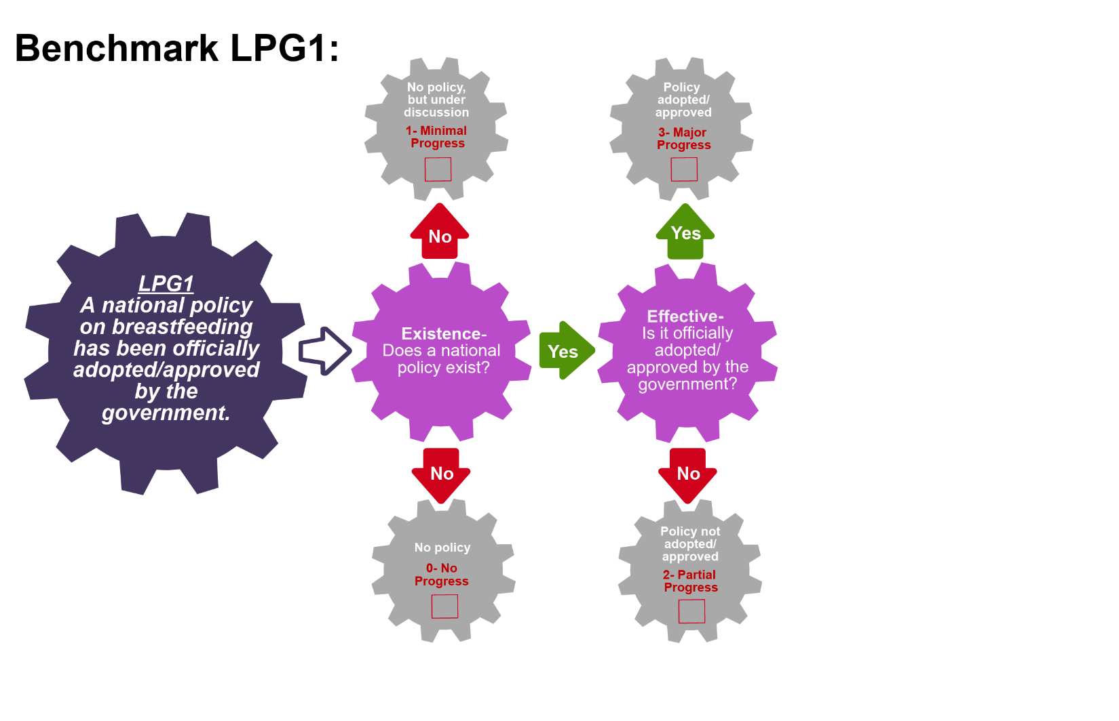
Scoring Pathway
☐
☐

☐

☐

**Insert the final score into the BBFI Calculator**
Instructions: Using the pathway, explain below the evolution of the final agreed score, i.e. rationale for any changes to the score, how the score was calculated (domains and criteria met), gaps identified and address any discrepancies of opinion within the Gear Team or Committee on the final score.
Date | Primary Score | Summary of Discussion | Scoring Justification | Final Score | Gaps identified
Between Meeting1 and 2

Date:
Meeting 2

Date:
Meeting 3

Date:
Data Organization: Please provide as much detail as possible to facilitate accurate scoring of each benchmark and development of recommendations. The relevant Domains are in bold.
LPG2: There is a national breastfeeding plan of action.
Existence:  Name of action plan and dates it covers | Existence:  Is this plan national or at state/regional level? | Quality:  List of strategies fully implemented | Quality:  List of identified measurable and time bound objectives/targets | References/ Data sources

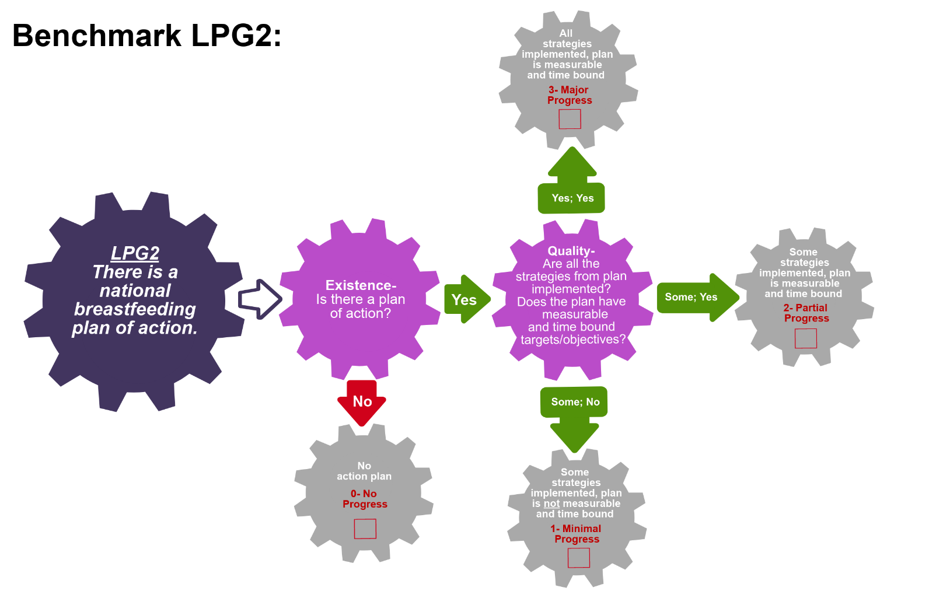
Scoring Pathway
☐

☐
☐

☐

**Insert the final score into the BBFI Calculator**
Instructions: Using the pathway, explain below the evolution of the final agreed score, i.e. rationale for any changes to the score, how the score was calculated (domains and criteria met), gaps identified and address any discrepancies of opinion within the Gear Team or Committee on the final score.
Date | Primary Score | Summary of Discussion | Scoring Justification | Final Score | Gaps identified
Between Meeting1 and 2

Date:
Meeting 2

Date:
Meeting 3

Date:
Data Organization: Please provide as much detail as possible to facilitate accurate scoring of each benchmark and development of recommendations. The relevant Domains are in bold.
LPG3: The national BFHI/Ten Steps criteria has been adopted and incorporated within the healthcare system strategies/policies.
Existence:  What is the national BFHI/Ten Steps criteria? | Quality:  Is it consistent with WHO/UNICEF global criteria? | Effective:  Explain how BFHI/Ten Steps is integrated into health care system strategies and policies. | References/ Data sources

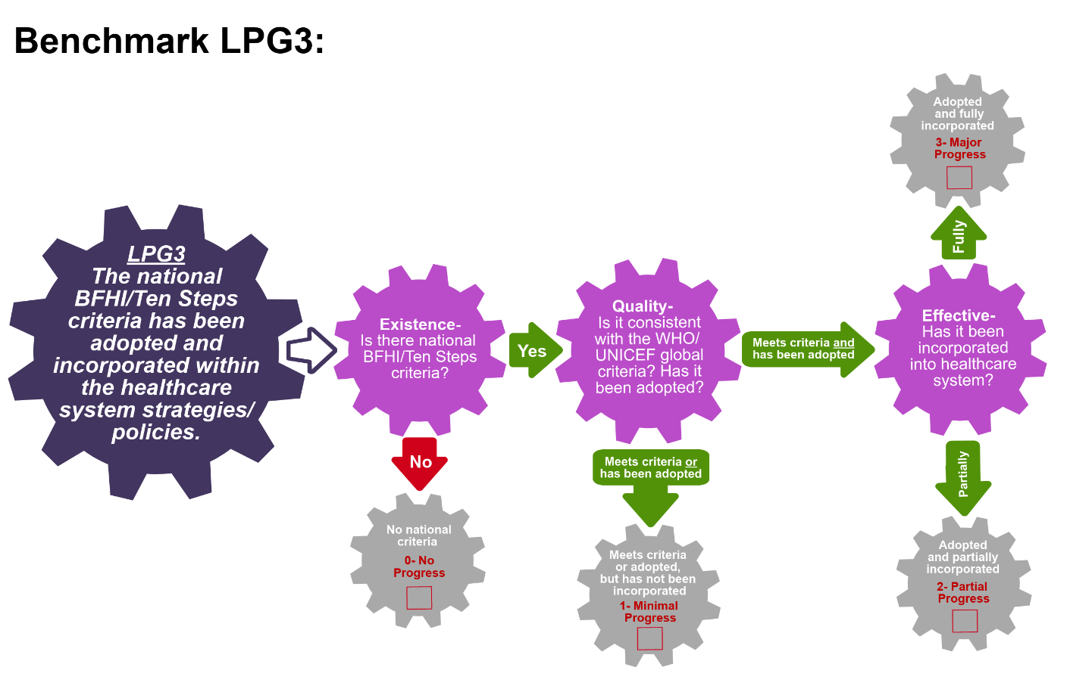
Scoring Pathway
☐
☐
☐
☐

**Insert the final score into the BBFI Calculator**
Instructions: Using the pathway, explain below the evolution of the final agreed score, i.e. rationale for any changes to the score, how the score was calculated (domains and criteria met), gaps identified and address any discrepancies of opinion within the Gear Team or Committee on the final score.
Date | Primary Score | Summary of Discussion | Scoring Justification | Final Score | Gaps identified
Between Meeting1 and 2

Date:
Meeting 2

Date:
Meeting 3

Date:

Data Organization: Please provide as much detail as possible to facilitate accurate scoring of each benchmark and development of recommendations. The relevant Domains are in bold.
LPG4: The International Code of Marketing of Breast Milk Substitutes has been adopted into legislation.
Existence:  Define the Code legislation, i.e. does it have the power of a law or is it voluntary? | Effective:  List the International Code provisions included in legislation | Quality:  Describe the monitoring system, reporting of violations and penalties for violators | References/ Data sources

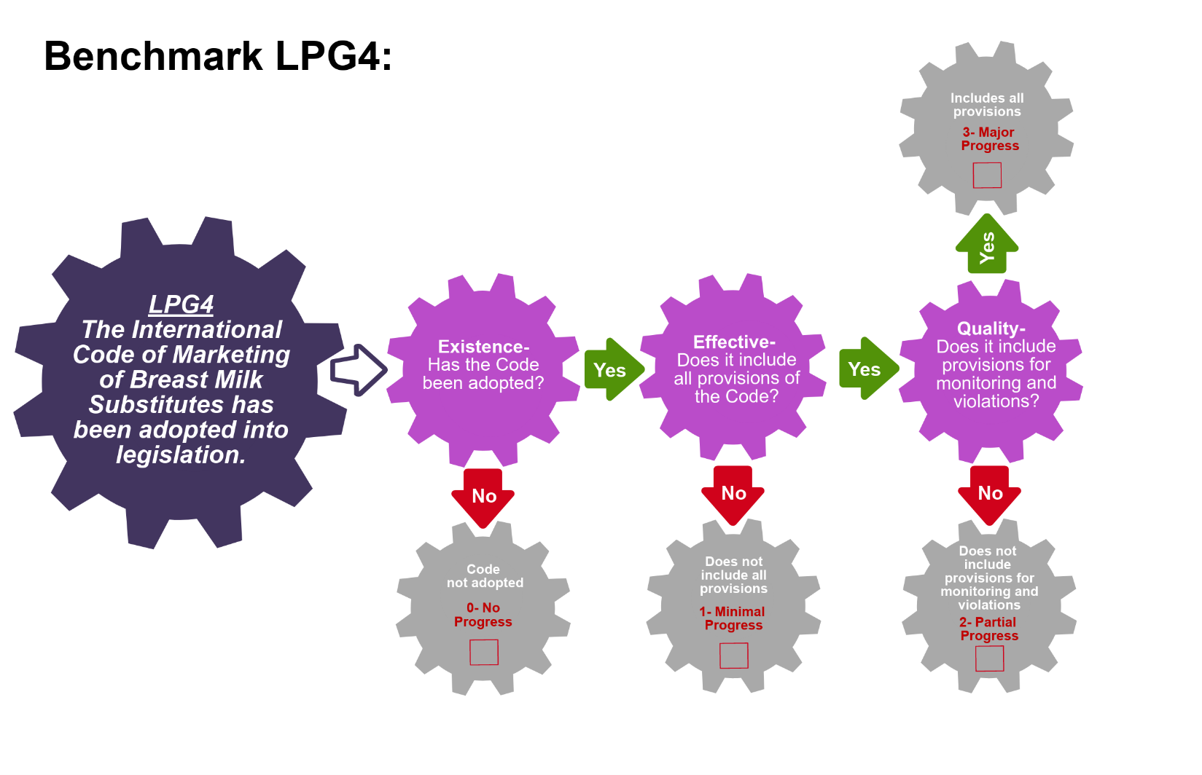
Scoring Pathway
☐
☐
☐
☐

**Insert the final score into the BBFI Calculator**
Instructions: Using the pathway, explain below the evolution of the final agreed score, i.e. rationale for any changes to the score, how the score was calculated (domains and criteria met), gaps identified and address any discrepancies of opinion within the Gear Team or Committee on the final score.
Date | Primary Score | Summary of Discussion | Scoring Justification | Final Score | Gaps identified
Between Meeting1 and 2

Date:
Meeting 2

Date:
Meeting 3

Date:
Data Organization: Please provide as much detail as possible to facilitate accurate scoring of each benchmark and development of recommendations. The relevant Domains are in bold.
LPG5: The National Code of Marketing of Breast Milk Substitutes has been enforced.
List the enforcement provisions with the adopted Code. | Coverage:  List the areas where enforcement is actively in place (localities or situations). Is the enforcement happening nationally or at state/regional level? | Coverage:  Provide all instances when enforcement took place in the last three years. Were penalties and sanctions proportional to the violations? | References/ Data sources

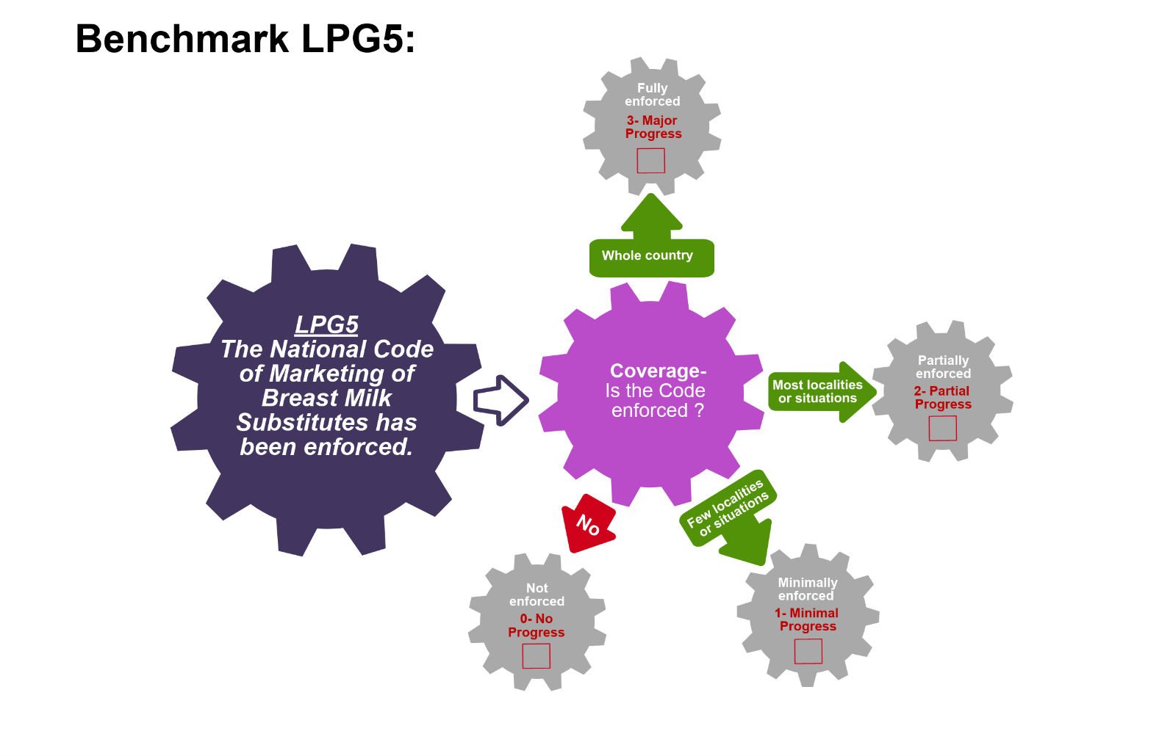
Scoring Pathway
☐
☐
☐

☐

**Insert the final score into the BBFI Calculator**
Instructions: Using the pathway, explain below the evolution of the final agreed score, i.e. rationale for any changes to the score, how the score was calculated (domains and criteria met), gaps identified and address any discrepancies of opinion within the Gear Team or Committee on the final score.
Date | Primary Score | Summary of Discussion | Scoring Justification | Final Score | Gaps identified
Between Meeting1 and 2

Date:
Meeting 2

Date:
Meeting 3

Date:
Data Organization: Please provide as much detail as possible to facilitate accurate scoring of each benchmark and development of recommendations. The relevant Domains are in bold.
LPG6: The International Labour Organization Maternity Protection Convention has been ratified.
Existence:  List all relevant maternity protection legislation, including any of the ILO's maternity conventions ratified | Quality:  List the provisions within the ILO's Maternity Protection Convention 2000 (No 183) met or exceeded by national legislation | References/ Data sources

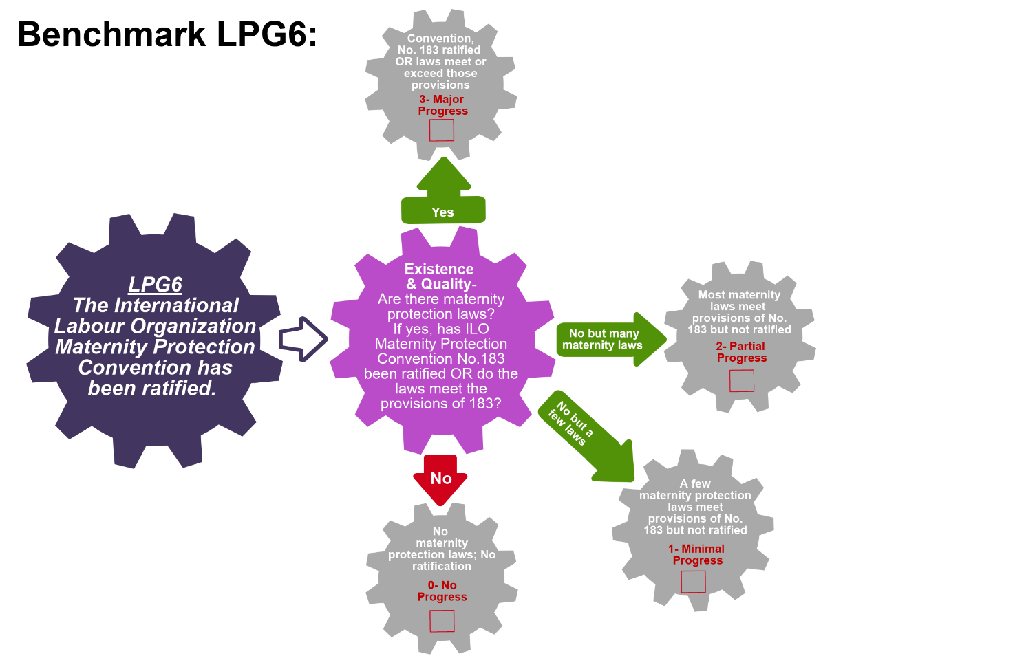
Scoring Pathway
☐
☐
☐
☐

**Insert the final score into the BBFI Calculator**
Instructions: Using the pathway, explain below the evolution of the final agreed score, i.e. rationale for any changes to the score, how the score was calculated (domains and criteria met), gaps identified and address any discrepancies of opinion within the Gear Team or Committee on the final score.
Date | Primary Score | Summary of Discussion | Scoring Justification | Final Score | Gaps identified
Between Meeting1 and 2

Date:
Meeting 2

Date:
Meeting 3

Date:
Data Organization: Please provide as much detail as possible to facilitate accurate scoring of each benchmark and development of recommendations. The relevant Domains are in bold.
LPG7: There is paid maternity leave legislation for women.
Existence:  Describe all relevant paid maternity legislation | Quality:  Do these provide for at least 14 weeks leave? | Quality:  Do these provide for at least 2/3rds of previous earnings? | References/ Data sources

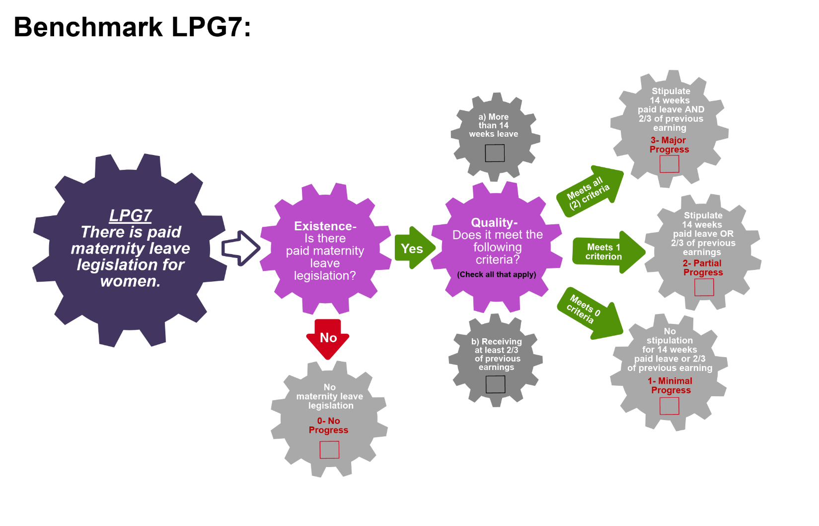
Scoring Pathway
☐
☐
☐
☐
☐

☐

**Insert the final score into the BBFI Calculator**
Instructions: Using the pathway, explain below the evolution of the final agreed score, i.e. rationale for any changes to the score, how the score was calculated (domains and criteria met), gaps identified and address any discrepancies of opinion within the Gear Team or Committee on the final score.
Date | Primary Score | Summary of Discussion | Scoring Justification | Final Score | Gaps identified
Between Meeting1 and 2

Date:
Meeting 2

Date:
Meeting 3

Date:

Data Organization: Please provide as much detail as possible to facilitate accurate scoring of each benchmark and development of recommendations. The relevant Domains are in bold.
LPG8: There is legislation that protects and supports breastfeeding/expressing breaks for lactating women at work.
Existence:  List all relevant policies and legislation supporting breastfeeding/expressing breaks | Coverage:  Are these at the local and/or national level? | References/ Data sources

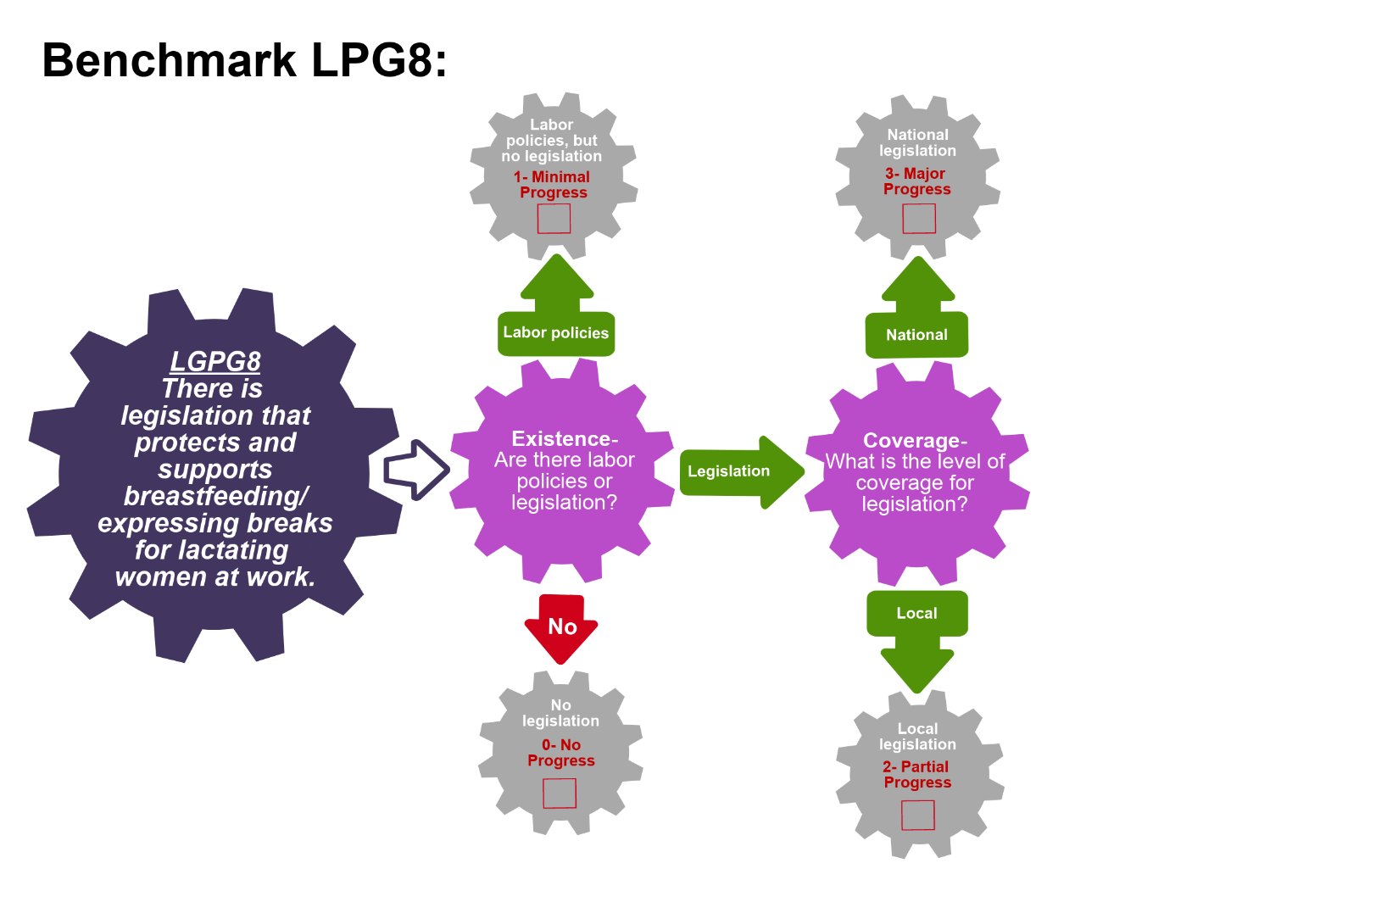
Scoring Pathway
☐
☐
☐
☐

**Insert the final score into the BBFI Calculator**
Instructions: Using the pathway, explain below the evolution of the final agreed score, i.e. rationale for any changes to the score, how the score was calculated (domains and criteria met), gaps identified and address any discrepancies of opinion within the Gear Team or Committee on the final score.
Date | Primary Score | Summary of Discussion | Scoring Justification | Final Score | Gaps identified
Between Meeting1 and 2

Date:
Meeting 2

Date:
Meeting 3

Date:

Data Organization: Please provide as much detail as possible to facilitate accurate scoring of each benchmark and development of recommendations. The relevant Domains are in bold.
LPG9: There is legislation supporting worksite accommodations for breastfeeding women.
Existence:  List all relevant policies and legislation supporting worksite accommodations for breastfeeding women | Coverage:  Are these at the local and/or national level? | References/ Data sources

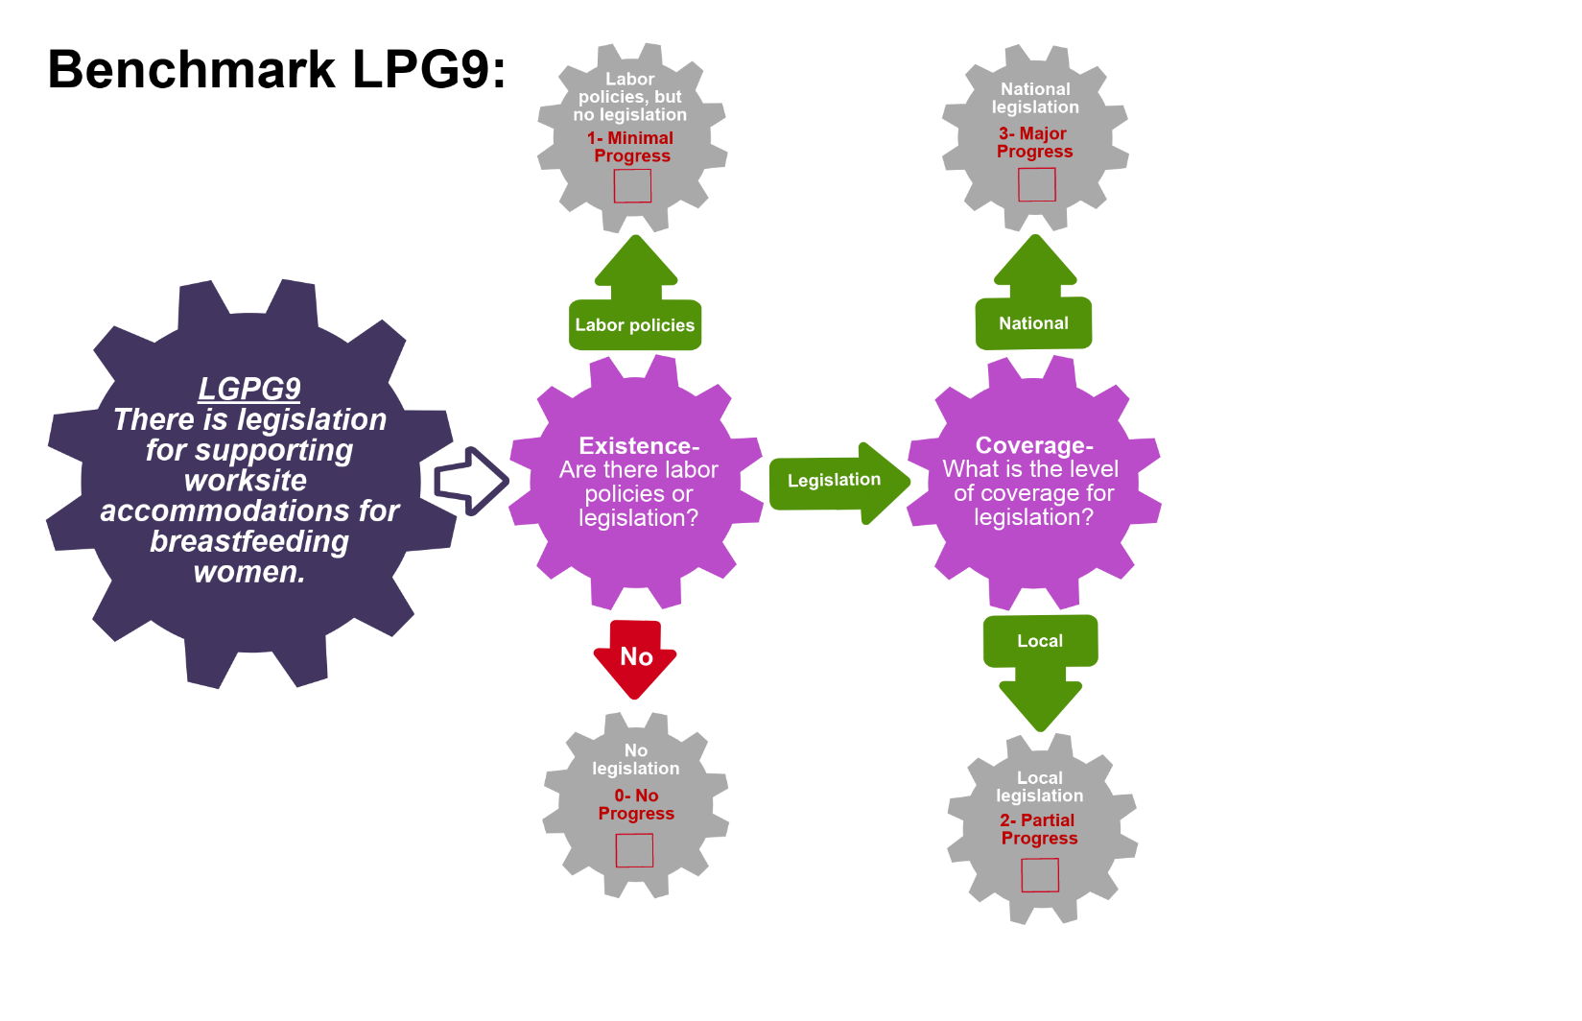
Scoring Pathway
☐
☐
☐
☐

**Insert the final score into the BBFI Calculator**
Instructions: Using the pathway, explain below the evolution of the final agreed score, i.e. rationale for any changes to the score, how the score was calculated (domains and criteria met), gaps identified and address any discrepancies of opinion within the Gear Team or Committee on the final score.
Date | Primary Score | Summary of Discussion | Scoring Justification | Final Score | Gaps identified
Between Meeting1 and 2

Date:
Meeting 2

Date:
Meeting 3

Date:

Data Organization: Please provide as much detail as possible to facilitate accurate scoring of each benchmark and development of recommendations. The relevant Domains are in bold.
LPG10: There is legislation providing employment protection and prohibiting employment discrimination against pregnant and breastfeeding women.
Employment protections: Affords women protection against termination; Provides guarantee of same position or equivalent pay until end of maternity leave; Prohibits requiring pregnancy tests upon hiring; Prohibits discrimination during employment for pregnant or breastfeeding women
Existence:  List all relevant policies and legislation prohibiting against discrimination and providing employment protections | Quality:  Does the legislation prohibit termination of employment? | Quality:  Does the legislation include protection of the same position and payment upon return from maternity leave? | Quality:  Does the legislation include protection against pregnancy tests upon hiring? Are there other employment protections for pregnant/ breastfeeding women? | References/ Data sources

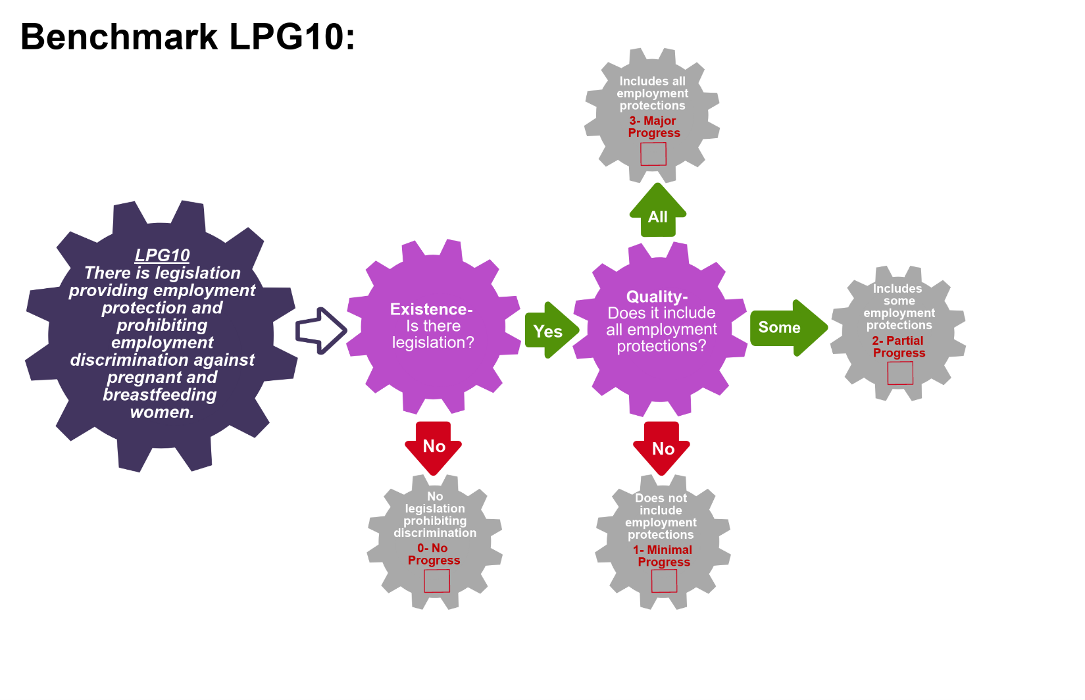
Scoring Pathway
☐
☐
☐
☐

**Insert the final score into the BBFI Calculator**
Instructions: Using the pathway, explain below the evolution of the final agreed score, i.e. rationale for any changes to the score, how the score was calculated (domains and criteria met), gaps identified and address any discrepancies of opinion within the Gear Team or Committee on the final score.
Date | Primary Score | Summary of Discussion | Scoring Justification | Final Score | Gaps identified
Between Meeting1 and 2

Date:
Meeting 2

Date:
Meeting 3

Date:

Recommended Actions
Legislation and Policies Gear (LPG)

This template can be used to summarize possible recommendations for improvement where benchmarks have scored No Progress (0), Minimal Progress (1) or Partial Progress (2). This summary will form the basis of each Gear Team’s presentation during Meeting 4. Guidance will be made available on developing recommendations and prioritizing them.
Gaps Identified | Recommended Actions

Adapted from the WBTi (2014).
Adapted from WHO’s Infant and Young Child Feeding assessment tool (2003)
Adapted from the WBTi (2014).
Adapted from the WBTi (2014).
Adapted from the WBTi (2014).
Adapted from the WBTi (2014).
Adapted from the WBTi (2014).

