BBF PI & Coordinator Package:
Advocacy Gear

This package contains information regarding the Advocacy Gear (AG) intended for the in-country BBF Team (PI, Coordinator and Research and/or Administrative Assistant) and BBF Committee Members. It is organized into the following sections:

- General description of the Advocacy Gear
- Advocacy Gear Benchmarks and Examples - Table of all AG Benchmarks, scoring information and examples
- Identification of Available Data- This template is to help the coordinator(s) in identifying the available data prior to the 1st Meeting. The BBF committee will use this form during that 1st Meeting to determine a) what remaining information is necessary and b) the actual benchmark scores. Provide as much detail as possible when completing this form to facilitate an efficient data gathering process.
- Data Gathering Action Plan- During the 1st Meeting, Gear Teams will set out their strategy to gather the remaining information required to score each benchmark to ensure efficient and comprehensive data collection. This plan should specify who is responsible, the likely data needed, the data collection strategy for each member, and the anticipated deadlines for collection.
- Data Organization and Benchmark Scoring Pathways- The purpose of the Data Organization templates are to help organize all the information collected for each benchmark and are intended to capture the multidimensional nature of each benchmark. The project coordinator ensures all data is available for the Gear Teams and they complete these forms. Teams will then use them in conjunction with the Scoring Pathways and corresponding tables to reach the benchmark score.

Scoring Pathways are designed to assist with the actual scoring - follow the arrows in order to score the benchmark. The corresponding tables are for documenting discussion, any changes to the scores, the scoring justification and final score. Gear Teams will summarize and present the results to the BBF committee during the 2nd and 3rd Meetings in order to facilitate consensus on benchmark scores.
- AG1
- AG2
- AG3
- AG4

- Recommended Actions - This table is for Gear Teams to outline/describe their proposed actions to address the gaps identified for the gear as a whole. These recommendations will form the basis of each Gear Team’s presentation during Meeting 4.
General description of the Advocacy Gear (AG)

Key question: Is evidence-informed, community-driven advocacy present and active to protect, promote and support breastfeeding?
Background

Global breastfeeding promotion efforts have intensified over the past decades with the release of international, evidence-based infant feeding recommendations in the early 1990s. International and local advocacy groups have been instrumental in translating these evidence-based breastfeeding recommendations into action to promote breastfeeding. Scaling-up breastfeeding promotion and support efforts require changing the political climate; by influencing the political will of politicians, legislation and policies supporting breastfeeding can be implemented.

The Breastfeeding Gear Model (BFGM) posits that evidence-informed, community-driven advocacy is necessary to generate political will. The presence of strong evidence-informed advocacy can lead to massive social mobilization and engagement of persons and resources, subsequently generating enough political pressure to influence political will. While there may be numerous in-country proponents of breastfeeding initiatives, advocacy efforts must be visible, impactful, consistent, and wide-reaching in order to generate enough social concern to push for political change. Media reports and/or social marketing campaigns can be effective delivery tools for disseminating key, appropriate, evidence-based breastfeeding advocacy messages

Benchmarks

The four benchmarks for the Advocacy Gear measure the presence and degree of advocacy to protect, promote and support breastfeeding scaling up efforts. They cover 1) public attention, 2) individual champions and 3) social cohesion/mobilization.
All benchmarks are referenced to “the past year” unless otherwise noted.

Domains

The benchmarks are designed to measure gear progress and they all have one or more Domain that assesses the different dimensions or elements within each benchmark:
Volume/Frequency: measures how much or how often
Quality: measures the quality of implementation
Effective (Operational): measures the adoption or level of incorporation
Existence: measure the actual presence of a program, legislation, policy, strategy, person, etc.
Coverage: measures the level of implementation (national, subnational, local)

Advocacy Gear (AG) Benchmarks and examples

Benchmark | Benchmark Scoring |  |  |  |  |  | Examples
 | 0  Not done |  | 1  Minimal progress | 2  Partial progress |  | 3  Major progress
AG1:  There have been major events that have drawn media attention to breastfeeding  issues. | No major events that have drawn media attention to breastfeeding issues. | One major event has drawn national media coverage to breastfeeding issues. |  | Two major events have drawn national media coverage to breastfeeding issues, at different times of the year. | Three or more major events have drawn national media coverage to breastfeeding issues, at different times of the year. |  | In 2016, Brazil has organized four major events that have drawn extensive media attention along the year: (1) The 2016 Lancet breastfeeding series (March) (2) National Day of Breastmilk Donation (May), (3) World Breastfeeding Week (August) and (4) National Conference on Breastfeeding (November).  Score: Major Progress  Existence: Yes  Volume: Three or more major event have drawn national media coverage to breastfeeding at different times during the year.
AG2:  There are high-level advocates (i.e. 'champions') or influential individuals who have taken on breastfeeding as a cause that they are promoting. | No high-level advocates or influential individuals have taken on breastfeeding as a cause that they are promoting. |  | One high-level advocate or influential individual has taken on breastfeeding as a cause he/she is promoting. | Two high-level advocates or influential individuals have taken on breastfeeding as a cause they are promoting. |  | Three or more high-level advocates or influential individuals have taken on breastfeeding as a cause they are promoting. | Alissa Milano, an actress in the US, uses social media to promote breastfeeding. She calls herself “a breastfeeding advocate” and uses the hashtag #normalizebreastfeeding to tweet and post about breastfeeding issues on Facebook and Instagram. Milan is also vocal about breastfeeding on television shows and popular magazines.  Score: Minimal Progress  Existence: Yes  Volume: One individual publicly promoted breastfeeding more than three times in one year. To score as major progress, there would need to be three or more high level advocates, also publicly promoting breastfeeding at least three times in the same year.
AG3:  There is a national advocacy strategy based on sound formative research. | There is no national advocacy strategy. |  | There is a national advocacy strategy but it is not based on formative research. | There is a national advocacy strategy that is based on formative research but it is not effective. |  | There is a national advocacy strategy that is grounded in the country’s context and it is effective. | One NGO, Alive & Thrive, who has a strong presence in Bangladesh and Vietnam, developed advocacy strategies using an evidence-based approach, which drew on global and national evidence, stakeholder mapping, and opinion leader research to inform breastfeeding advocacy policy strategies. Experience demonstrates that an evidence-based advocacy program design is feasible and can contribute to policy and advocacy goals ranging from the adoption and strengthening of national laws to increasing investments in IYCF.  In Viet Nam, A&T had four prongs to their advocacy strategy based on their extensive research: Develop and sustain partnerships, Build a continuous evidence base, Strategic Communication and Interpersonal and Group Communication. To understand the quality of the implementation, they compared baseline data against data collected again three years into the strategy. They used Event Tracking to analyze and understand the causes of any shifts in the overall policy environment during the strategy’s timeframe.  To capture the impact of these strategies, additional evaluations were carried out, such as stakeholder interviews and content analysis of provincial nutrition plans in Viet Nam and media content analysis and stakeholder interviews in Bangladesh.  In 2012, Viet Nam’s National Assembly extended paid maternity leave from 4 to 6 months – and it passed with more than 90% of votes and in Bangladesh, there was a marked increase in in-depth and frequent IYCF news coverage.  Score: Major Progress  Existence: Yes  Quality: National advocacy strategies developed by A&T were based on sound formative research.  Effective: Strategies were operational, i.e. they were strategically implemented and generated support for breastfeeding protection, promotion and support.
AG4: A national cohesive network(s) of advocates exists to increase political and financial commitments to breastfeeding. | There is no national cohesive network(s) of advocates to increase political and financial commitments to breastfeeding |  | A cohesive network(s) of advocates exists to increase political and financial commitments to breastfeeding but only to a limited extent, i.e. they only have local coverage. | A cohesive network(s) of advocates exists to increase political and financial commitments to breastfeeding to some extent i.e. they only have subnational coverage. |  | A cohesive network(s) of advocates exists to increase political and financial commitments to breastfeeding to some extent i.e. they only have subnational coverage. | The Breastfeeding Promotion Network of India (BPNI) is a registered, independent, nonprofit and national network of 57 organizations within the country working together to protect, promote and support breastfeeding and optimal infant feeding practices. Their founder and Central Coordinator is the highly visible and respected doctor, Arun Gupta. BPNI has representation on the National Infant and Young Child Feeding Coordination Committee and the National Infant and Young Child Feeding Steering Committee (both government bodies), the Working Group on Children's Right to Food, and the National Coordination Committee of Jan SwasthyaAbhiyan (People’s Health Movement). Their advocacy activities include: media campaigns (https://www.facebook.com/Babies-Need-Mom-Made-Not-Man-Made-301758009914509/), parliamentary questions and direct advocacy with government ministries, newsletters, academic papers, magazine and newspaper articles, presentations nationally and internationally and an app for the public to report Code violations.  BPNI is a part of a global network, the International Baby Food Action Network (IBFAN), an umbrella organization comprising advocacy groups working, “through programmes designed for increasing its outreach by building alliances, protecting people from baby food corporations’ misleading propaganda, advocating with governments to hold the baby food corporations accountable, providing technical and planning support to governments, campaigning, training and capacity building.”  Score: Major Progress  Existence: Yes, BPNI includes more than two advocate groups.  Coverage: BPNI has national coverage

Identification of Available Data
Advocacy Gear
This template is to help the coordinator in identifying the available data the national BBF committee will use to score the AG benchmarks. Provide as much detail as possible when completing this form to facilitate an efficient data gathering process.
Instructions: For each benchmark, the data required is described. Indicate in the Available Data column if that data is available: Yes (Y), No (N), Incomplete (I) or Don’t Know (DK).
Benchmark | Description of required data | Available Data  (Y/N/I/DK) | Reference/Data Sources  Describe where this data is located (e.g. website, report, person to interview, etc.)
AG1: Have there been major events that have drawn media attention to breastfeeding issues? | Domain: Existence:  What were the events?  Domain: Volume:  When/how often were they events? What was the level of coverage in the media?  NOTE 1: Major events include conferences, gatherings, reports, photos, TV ads, or anything planned that galvanized advocacy efforts  NOTE 2: Local media sources can be included in the scoring if they led to national level media attention.  NOTE 3: Both positive and negative media attention can be considered in the scoring, if they galvanized public attention towards advocating for breastfeeding.
AG2: There are high-level advocates (i.e. champions) or influential individuals who have taken on breastfeeding as a cause that they promote. | Domain: Existence:  Who are the high-level advocates?  Domain: Volume:  How and when did they advocate for breastfeeding in the last year?
 | NOTE: High-level advocates can include individuals such as traditional/ religious/social leaders, public figures, social media bloggers, and former political figures.
AG3: There is a national advocacy strategy based on sound formative research. | Domain: Existence:  This may include national, state or local advocacy strategies that are specific to breastfeeding or reference breastfeeding advocacy. Does the country/region/state have any such advocacy strategies?  Domain: Quality  If so, how were they developed? What evidence was used?  Domain: Effective:  How is implementation monitored?
 | NOTE: A national/ state/local advocacy strategy is a governmental or non-governmental document or initiative that aims to organize and/or systematize breastfeeding advocacy actions within the country.
AG4: A national cohesive network(s) of advocates exist to increase political and financial commitments to breastfeeding | Domain: Existence:  Describe what networks exist (number of partners)  Domain: Coverage:  Level of coverage of the network(s), the breastfeeding advocacy objectives, and any collective agenda, strategy, event, etc.

Data Gathering Action Plan
Advocacy Gear (AWG)
This plan describes the strategy to gather information required to score each benchmark. The action plan must include a schedule of regular meetings or conference calls made in the intervening two months between Meeting 1 and Meeting 2. It is during this period that the Gear Teams must score their benchmarks.
Gear Team Members:

Benchmark | Assigned Team member(s) | Potential Data Sources | Data Collection Strategy
AG1: There have been major events that have drawn media attention to breastfeeding issues.
AG2: There are high-level advocates (i.e. 'champions') or influential individuals who have taken on breastfeeding as a cause that they are promoting.
AG3: There is a national advocacy strategy based on sound formative research.
AG4: A national cohesive network(s) of advocates exists to increase political and financial commitments to breastfeeding.

Scheduled Meetings: Describe the dates/times, methods (i.e., skype, in person) and content of anticipated meetings.
Date | Time | Method  (skype, in person, etc.) | Meeting agenda items | Anticipated attendees

Data Organization & Scoring Pathways
Advocacy Gear
Data Organization: Please provide as much detail as possible to facilitate accurate scoring of each benchmark and development of recommendations. The relevant Domains are in bold.
AG1: Have there been major events that have drawn media attention to breastfeeding issues?
NOTE: 1) Major events include conferences, gatherings, reports, photos, TV ads, or anything planned that galvanized advocacy 2) Local media sources can be included in the scoring if they led to national level media attention. 3) Both positive and negative media attention can be considered in the scoring, if they galvanized public attention towards advocating for breastfeeding.
Existence:  Breastfeeding Event (list each event) | Volume:  What level did the event reach? (i.e. national, state, subnational, local, etc.) | Volume:  When did the event(s) occur? | References/ Data sources

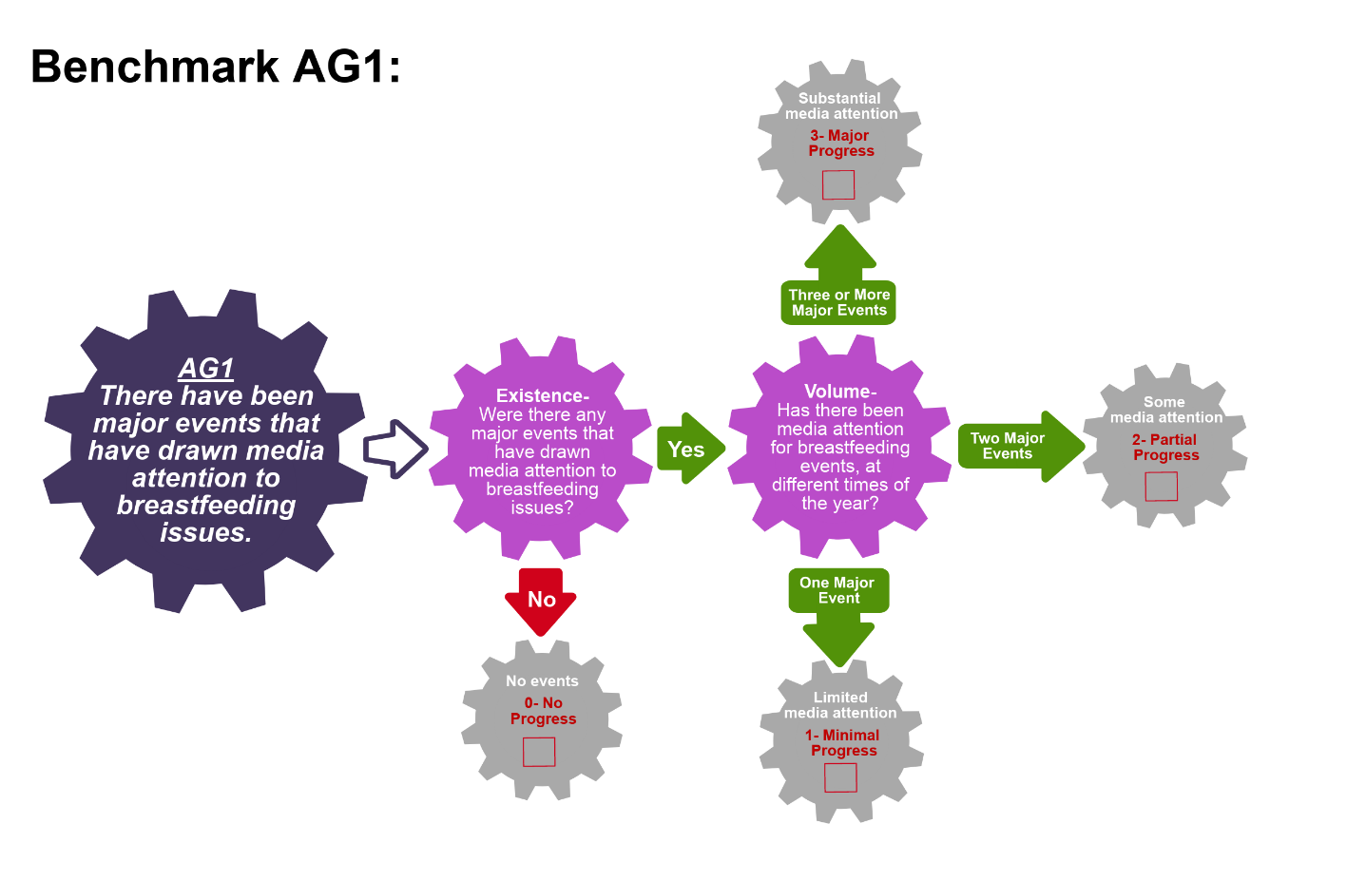
Scoring Pathway
☐

**Insert the final score into the BBFI Calculator**
☐
☐
☐
Instructions: Using the pathway, explain below the evolution of the final agreed score, i.e. rationale for any changes to the score, how the score was calculated (domains and criteria met), gaps identified and address any discrepancies of opinion within the Gear Team or Committee on the final score.
Date | Primary Score | Summary of Discussion | Scoring Justification | Final Score | Gaps identified
Between Meeting1 and 2

Date:
Meeting 2

Date:
Meeting 3

Date:

Data Organization: Please provide as much detail as possible to facilitate accurate scoring of each benchmark and development of recommendations. The relevant Domains are in bold.
AG2: There are high-level advocates (i.e. champions) or influential individuals who have taken on breastfeeding as a cause that they promote.
NOTE: High-level advocates can include individuals such as traditional/religious/social leaders, public figures, social media bloggers, as well as former political figures.
Existence:  List the names of possible high-level advocate/ champion for breastfeeding | Existence:  Define the person’s role (e.g. work this person does and reach of audience) | Volume:  How is this person an advocate for breastfeeding (i.e. list what they have done in the last year) | Volume:  Number of different times this person advocated for breastfeeding in the past year | References/ Data sources

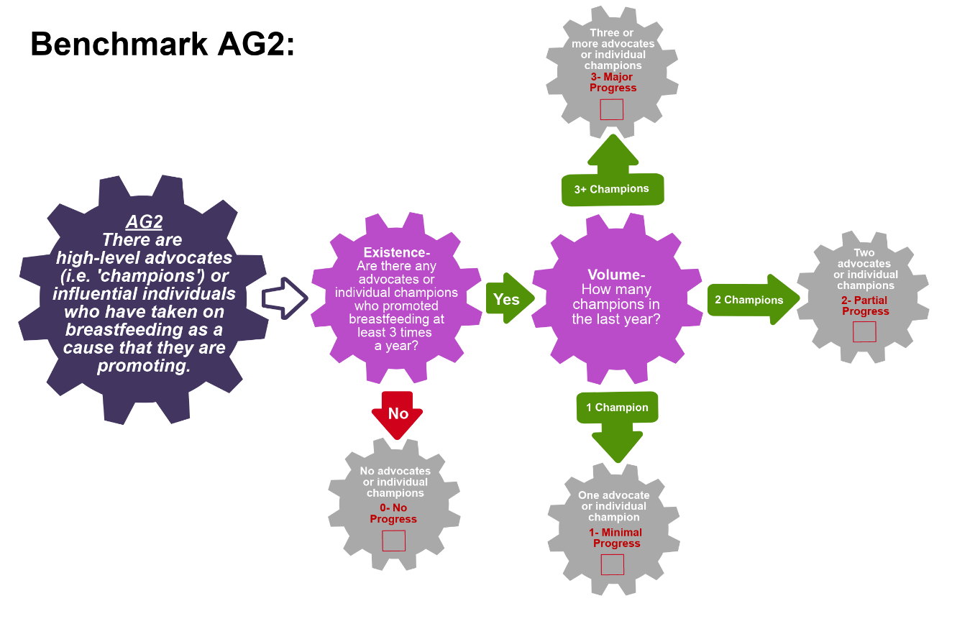
☐
☐
☐
Scoring Pathway

☐

**Insert the final score into the BBFI Calculator**
Instructions: Using the pathway, explain below the evolution of the final agreed score, i.e. rationale for any changes to the score, how the score was calculated (domains and criteria met), gaps identified and address any discrepancies of opinion within the Gear Team or Committee on the final score.
Date | Primary Score | Summary of Discussion | Scoring Justification | Final Score | Gaps identified
Between Meeting1 and 2

Date:
Meeting 2

Date:
Meeting 3

Date:

Data Organization: Please provide as much detail as possible to facilitate accurate scoring of each benchmark and development of recommendations. The relevant Domains are in bold.
AG3: There is a national advocacy strategy based on sound formative research
NOTE: A national/state/local advocacy strategy is a governmental or non-governmental document or initiative that aims to organize and/or systematize breastfeeding advocacy actions within the country. This could be specific to breastfeeding or include breastfeeding advocacy.
Existence:  Name of advocacy strategy | Existence:  What level does the strategy target? (i.e. national, state, subnational, local, etc.) | Quality:  How were the goals developed? What formative research was undertaken? | Effective:  Is there a monitoring system in place for the strategy? How is the impact measured? | References/ Data sources

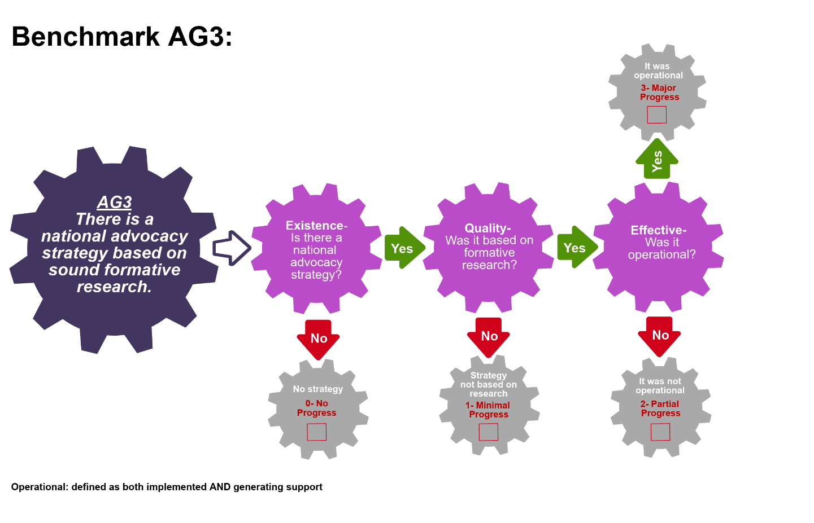
☐
Scoring Pathway

☐

☐
☐

**Insert the final score into the BBFI Calculator**
Instructions: Using the pathway, explain below the evolution of the final agreed score, i.e. rationale for any changes to the score, how the score was calculated (domains and criteria met), gaps identified and address any discrepancies of opinion within the Gear Team or Committee on the final score.
Date | Primary Score | Summary of Discussion | Scoring Justification | Final Score | Gaps identified
Between Meeting1 and 2

Date:
Meeting 2

Date:
Meeting 3

Date:
Data Organization: Please provide as much detail as possible to facilitate accurate scoring of each benchmark and development of recommendations. The relevant Domains are in bold.
AG4: A national cohesive network(s) of advocates exist to increase political and financial commitments to breastfeeding
NOTE: A network is formed by two or more advocate groups and is considered cohesive when they work collectively. The network needs to include breastfeeding advocacy as a key focus but it does not need to be the only advocacy issue it defends.
Existence:  Is there a network of two or more advocacy groups that includes breastfeeding advocacy? (List network(s)) | Existence:  Does the network have a collective agenda, strategy, event, or goals, etc.? (yes/no, more description can be added in the notes section) | Coverage:  What level does this network exist on? (National, state, subnational, local, etc.) | References/ Data sources

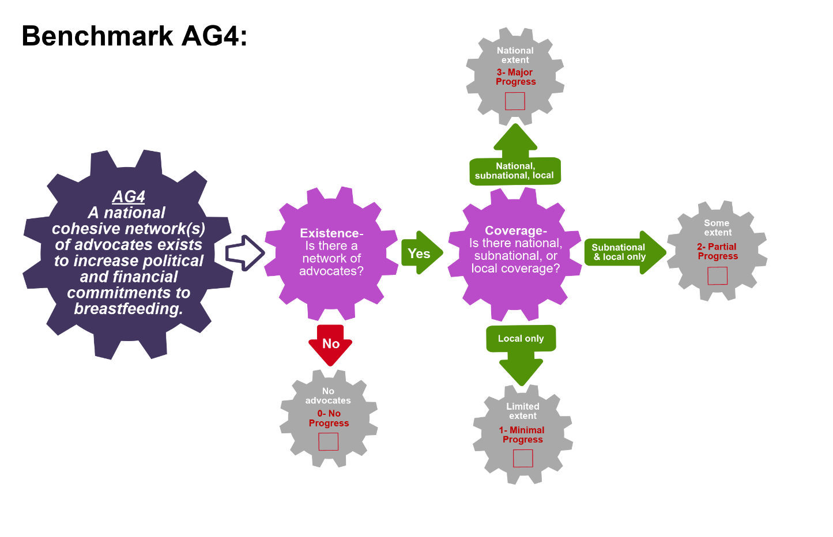
Scoring Pathway

☐

☐
☐
☐

**Insert the final score into the BBFI Calculator**
Instructions: Using the pathway, explain below the evolution of the final agreed score, i.e. rationale for any changes to the score, how the score was calculated (domains and criteria met), gaps identified and address any discrepancies of opinion within the Gear Team or Committee on the final score.
Date | Primary Score | Summary of Discussion | Scoring Justification | Final Score | Gaps identified
Between Meeting1 and 2

Date:
Meeting 2

Date:
Meeting 3

Date:

Recommended Actions
Advocacy Gear (AG)
This template can be used to summarize possible recommendations for improvement where benchmarks have scored No Progress (0), Minimal Progress (1) or Partial Progress (2). This summary will form the basis of each Gear Team’s presentation during Meeting 4. Guidance will be made available on developing recommendations and prioritizing them.
Gaps Identified | Recommended Actions

Adapted from Fox et al. (2015)
Adapted from Fox et al. (2015)

